**TASK 1**

**Objective:**

Apply standard library functions.

1. Input character array from user.Find the length of string.(strlen)
2. Input two character array.Copy the elements of first to second array.(strcpy)
3. Input two character array.Compare both arrays.(strcmp)
4. Input two character array.Concatenate the elements of both arrays(strcat)

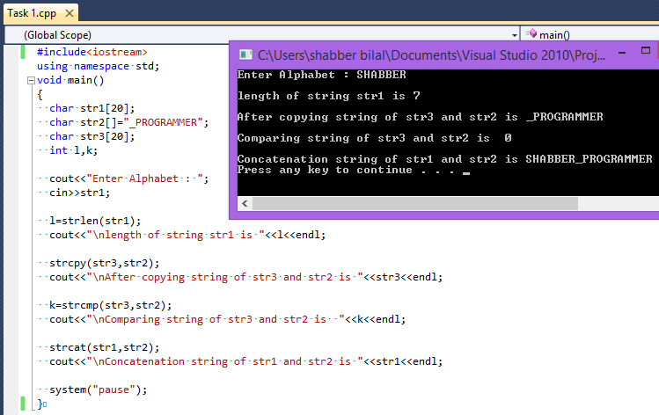

**TASK 2**

**Objective:**

Write a program that contains user defined function xstrlen that calculates the length of string.

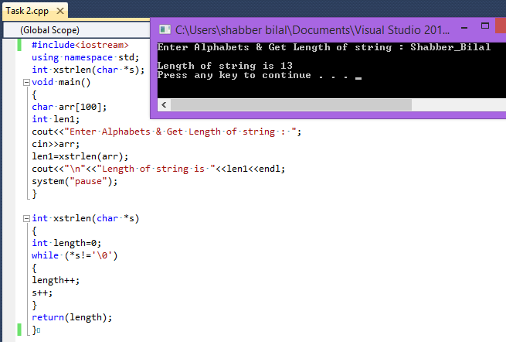

**TASK 3**

**Objective:**

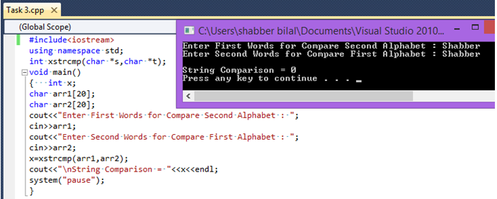Write a program that contains user defined function xstrcmp that compares two string.

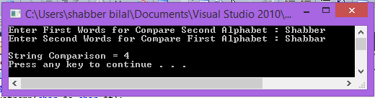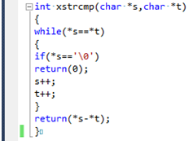

**TASK 4**

**Objective:**

Write a program that contains user defined function xstrcpy that copies ont string to another.

